**Interactive water management map of Wellington**

**Cartography Lab**

**ETHZ, FS 16**

**Professor:**

Prof Dr Lorenz Hurni

**Supervisors:**

Dr Christian Häberling

Dr Hans-Rudolf Bär

**Students:**

Giulio Tagliaferro [giuliot@ethz.ch](mailto:giuliot@ethz.ch)

Matteo Lehmann [mlehmann@ethz.ch](mailto:mlehmann@ethz.ch)

Zurich, 28 June 2016

**Table of content**

1. Introduction 3

2. Objectives of the Cartography Lab 4

3. Basic data 4

4. Technical equipment 5

5. Project steps and implementation 5

6. Results 5

7. References 5

**List of Figures**

**Figure 1:** Sewage system of London, 1882 (Ancestry, 2016) 3

**Figure 2:** Drainage system of London, 1950s (H&H Geological Society, 2016) 4

**Figure 3:** Representation of Pipe inspector with further information 5

# Introduction

Water-supply and water collection is a vital part of the infrastructure of a city. Although this system could be hidden and not visible, it is still essential to maintain clean and tidy every city around the world.

Could be interesting to point out that in most of the countries the ensemble of the water networks (supply, drainage and treatment) is the most valuable asset of a city.

In Figure 1 and Figure 2 there are shown examples of respectively the water treatment and the drainage system maps of London. The topic has not been treated extensively in cartography. This kind of networks are usually represented only in cadastral maps together with gas and electrical networks.

The choice of Wellington as location for the thematic map is basically based on two main reasons: this kind of data are generally not provided free of charge (e.g. cadaster of Zurich). The city of Wellington makes these kind of data freely available. Furthermore, the city of Wellington has an astonishing number of free available data included numerous layers covering almost every topic.

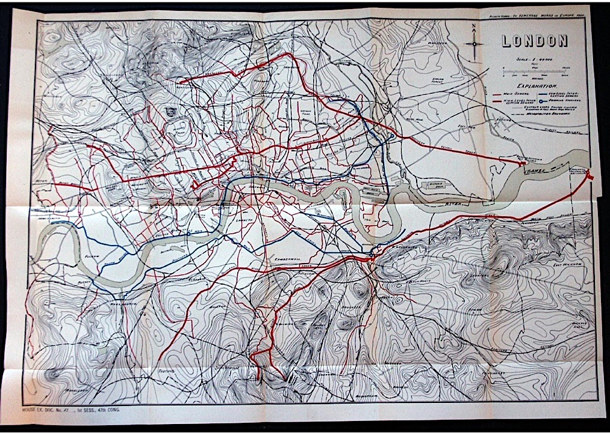

**Figure 1:** Sewage system of London, 1882 (Ancestry, 2016)

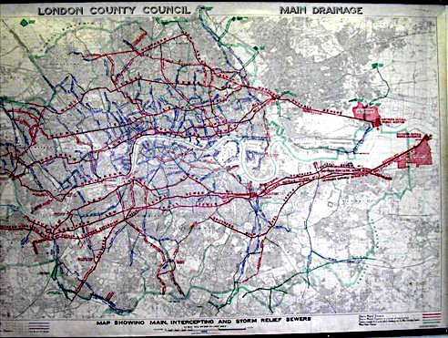

**Figure 2:** Drainage system of London, 1950s (H&H Geological Society, 2016)

# Objectives of the Cartography Lab

The main idea behind of this Cartography Lab is to create an interactive map based on the water management in Wellington, New Zealand.

Principally, the target audience is an extended group consisting of citizens, students but also specialized workers. The map will be Web-based and accessible to a broad public and it will provide a faster and easier way to graphically visualize the network and its properties. The final product will be published on the Web and it could potentially be linked to the City Council Web Site[1].

It is important to notice that the final product of this Cartography Lab is only a prototype. This means that we developed a lot of possible interaction between user and application but the content is extended only on storm water and waste water management.

# Basic data

The data have been downloaded from a NZ geoportal (<https://koordinates.com/>) from which the Shapefiles of the supply, drainage and treatment networks can be freely downloaded.

All the data are published using two licenses: the *CC BY-SA 3.0 (Attribution-ShareAlike 3.0 Unported)[2]* for basemap data such as DSM and municipality boundaries and the *CC BY-NC 3.0 NZ (Attribution-NonCommercial 3.0 New Zealand)[3]* for the data of the networks.

The content of the interactive map will be mainly based on two topics: the “Waste Water” and the “Rain Water” networks. Those are the two main parts of the content.

The two layers are supported by further information regarding: materials, diameter, slope, and year of construction (or maintenance).

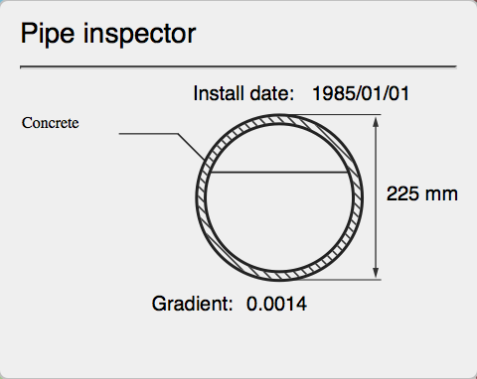

**Figure 3:** Representation of Pipe inspector with further information

The evolution of the networks in time can be easily observed by selecting a specific year with the time slider.

As basemap we considered to use a prebuild map from MapBox, in which there are shown only the most significant objects: streets, buildings, parks, ocean, and rivers. Furthermore, we added to the basemap also a DTM-5m because it is important to understand the downflow of the water in the pipes.

# Technical equipment

The technologies used are *html* for the GUI, CSS for the style and Javascript for the interaction. Furthermore, cartographic dedicated libraries are used (Leaflet D3, Openlayers, JQuery, etc.).

# Project steps and implementation

# Results

# References

* Ancestry, 2016:

<http://freepages.genealogy.rootsweb.ancestry.com/~genmaps/genfiles/COU_files/ENG/LON/hering_lon-sewer_1882.html>

H&H Geological Society, 2016:

<http://www.hhgs.org.uk/monthly_meetings/previous_meetings/thames_tideway/thames_tideway.html>

1. **City Council Web Site**: http://wellington.govt.nz
2. # Source: http://creativecommons.org/licenses/by-sa/3.0/

  
3. # Source: http://creativecommons.org/licenses/by-nc/3.0/nz/

  